Presented By

Y.A.O.D. Yapa – AS2017956

ICT 334 2.0 Project

Department of Computer Science

Faculty of Applied Sciences

University of Sri Jayewardenepura

|  |  |
| --- | --- |
| Aswenna App  Realtime Products Selling App for Famers | Abstract  This application is basically about managing productions of farmers in Sri Lanka. Basically, it clearly makes direct interconnection among farmers and buyers. It may avoid the wastage because of being unable to find market and reduce the cost for brokers.  Final Report |

# ACKNOWLEDGEMENT

First I would like to express my heartfelt gratitude to my supervisor, Dr.T.M.K.K.Jinasena, Senior Lecturer in Computer Science, Department of Computer Science, Faculty of Applied Sciences, University of Sri Jayewardenepura, for his guidance, expertise, and sincere and encouraging words extended to me during the project's preliminary stages,

as well as providing me with experiences. Prof. Laleen Karunanayake, Dean, Faculty of Applied Sciences, University of Sri Jayewardenepura, for his valuable guidance, and Dr. Prasad Jayaweera, Head of the Department of Computer Science, Faculty of Applied Sciences, University of Sri Jayewardenepura, for his advice and vital contribution to this project, are acknowledged.

I also want to thank Mr. Ravimal Bandara, lecturer at the Faculty of Applied Sciences, University of Sri Jayewardenepura, as well as the overall coordinator for project activities, for his instructions, as well as all of the faculty members at the Faculty of Applied Sciences, University of Sri Jayewardenepura, for their assistance and support. I'd also like to express my heartfelt appreciation to all of the respondents who helped me gather data and made this project a success.

Finally, I owe a debt of gratitude to my friends and the rest of the people who supported me; their names are not listed, but their tireless efforts were instrumental in making this project a success.

# DECLARATION

I, Y.A.O.D.Yapa, bearing Index Number AS2017956 student of the University of Sri Jayewardenepura's Computer Science department, hereby declare that I am solely responsible for the material, performance, and other content contained in this project titled "Aswenna" submitted to the University of Sri Jayewardenepura for the third year Information Communication Technology project. My supervisor should not be held responsible for any copyright or intellectual property rights violations, whether complete or partial.

Contents

ACKNOWLEDGEMENT 1

DECLARATION 2

Table of Figure 4

Introduction 5

Methodology 6

Result 7

Loading Screen 7

Sign in Screen 8

Sing Up Screen 9

Password Recovery Screen 10

Gmail Sing In 11

Facebook Sign In 12

Collect User Data Screens 13

Customers Dashboard Screen 16

Farmers Dashboard Screen 19

Customer Product Details Screen 21

Farmer Product Detail Screen 22

Edit Product Option 23

Edit Product Screen 24

Delete Product Option 26

Add Product Screen 28

Image Upload Screen 30

Some Other Screens and Windows. 31

Discussion 34

Conclusion 35

Reference 36

# Table of Figure

Figure 1 - Loading Screen 7

Figure 2 - Sign in Screen 8

Figure 3 - Sign Up Screen 9

Figure 4 - Password Reset Screen 10

Figure 5 - Gmail Sign in Screen 11

Figure 6 - Facebook Sign in Screen 12

Figure 7 - Collect User Data Screen 01 13

Figure 8 - Collect User Data Screen 02 14

Figure 9 - Collect User Data Screen 03 15

Figure 10 - Customer Dashboard All 16

Figure 11 - Customer Dashboard Vegetables 17

Figure 12 - Customer Dashboard Fruits 18

Figure 13 - Farmer Dashboard All 19

Figure 14 - Farmer Dashboard Vegetables 20

Figure 15 - Customer Product Detail Screen 21

Figure 16 - Farmer Product Detail Screen 22

Figure 17 - Product Edit Option 23

Figure 18 - Product Edit Screen 01 24

Figure 19 - Product Edit Screen 02 25

Figure 20 - Product Delete Option 26

Figure 21 - Product Delete Confirmation 27

Figure 22 - Add New Product Screen 01 28

Figure 23 - Add New Product Screen 02 29

Figure 24 - Image Upload Screen 30

Figure 25 - App Drawer 31

Figure 26 - Product Selection Screen Vegetable 32

Figure 27 - Product Selection Screen Fruit 33

# Introduction

This application is basically about managing productions of farmers in Sri Lanka. Basically, it clearly makes direct interconnection among farmers and buyers. It may avoid the wastage because of being unable to find market and reduce the cost for brokers. By using these App farmers can list their products with their market price before they harvesting. Then in other side buyers can view what they need and contact farmers directly without brokers. I hope to give more advice for farmers to minimize wastage of their products.

# Methodology

* This mobile app war created using Flutter framework with Dart language.
* Whole front end developed using flutter and backend develop by firebase.
* Here I used to google authentication for google account sign in and Facebook authentication for Facebook account sign in. and also developed email sign up with firebase.
* Here I placed the link of relevant code and all data of the “Aswenna” App.

<https://github.com/Dewruwan95/FarmersProjest-Aswenna>

# Result

## Loading Screen

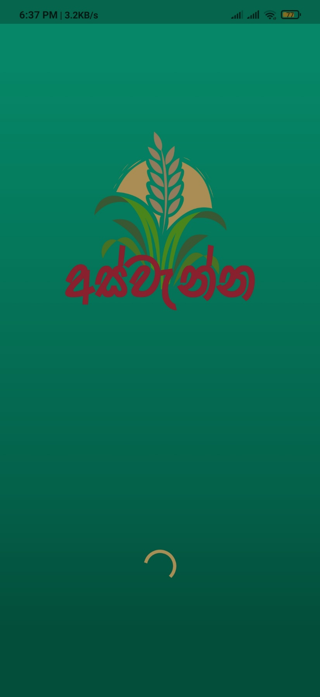

Figure 1 - Loading Screen

## Sign in Screen

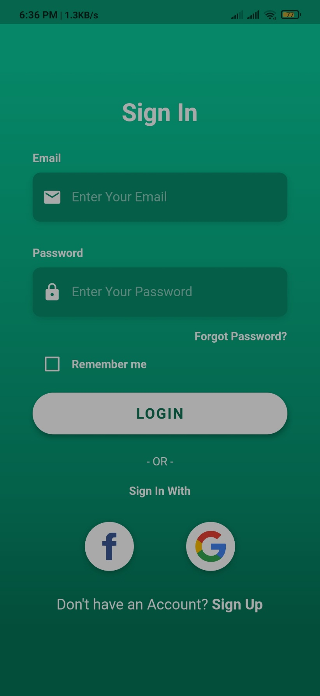

Figure 2 - Sign in Screen

## Sing Up Screen

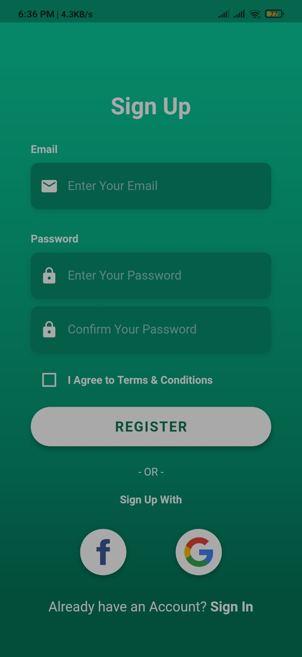

Figure 3 - Sign Up Screen

## Password Recovery Screen

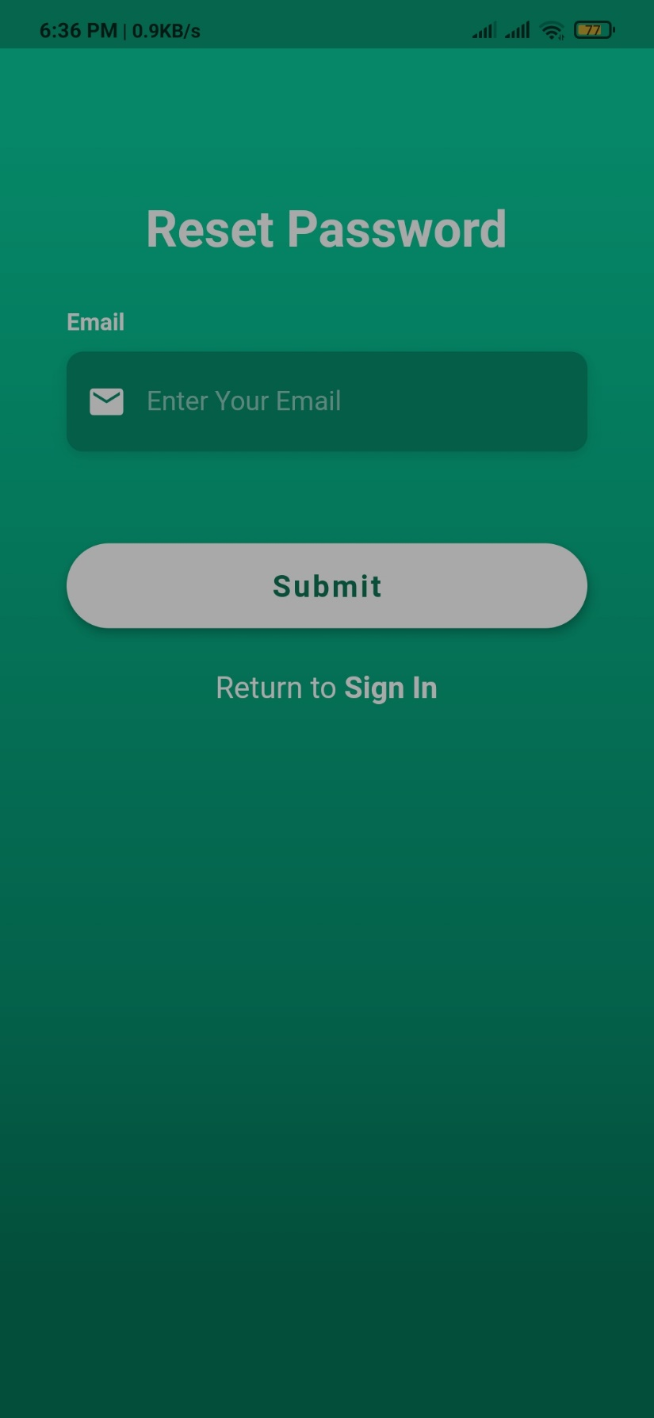

Figure 4 - Password Reset Screen

## Gmail Sing In

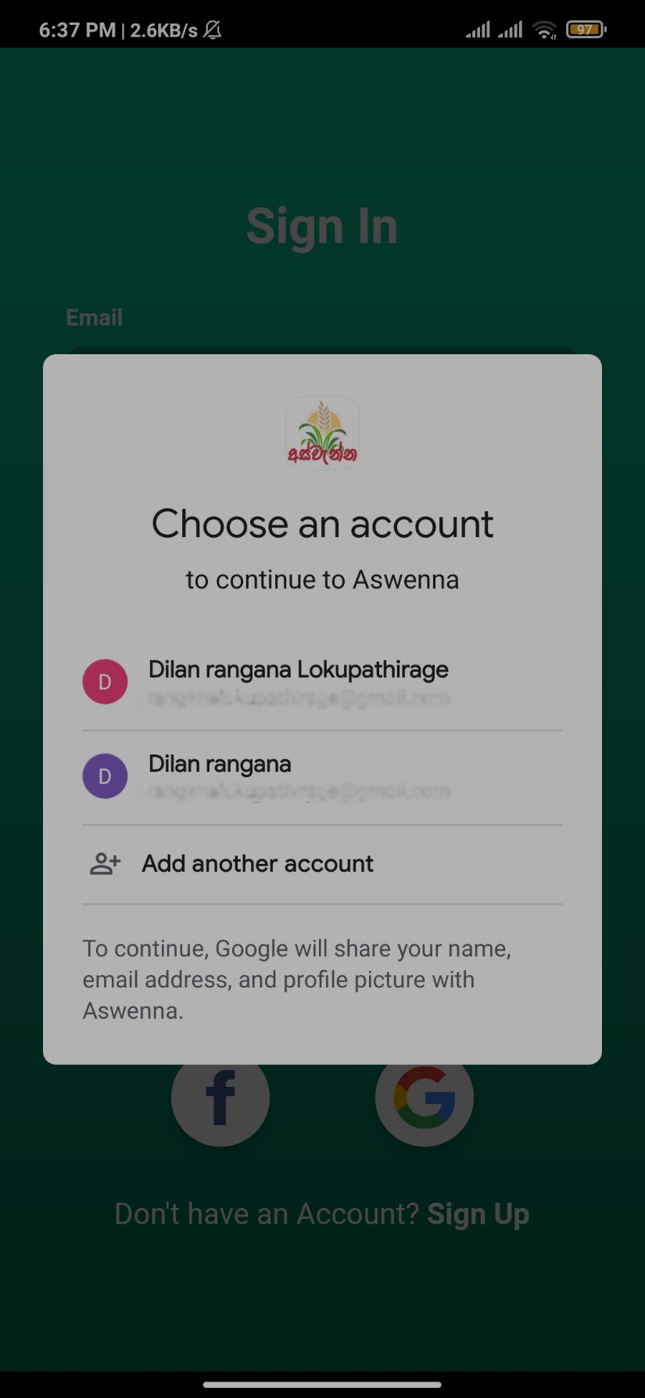

Figure 5 - Gmail Sign in Screen

## Facebook Sign In

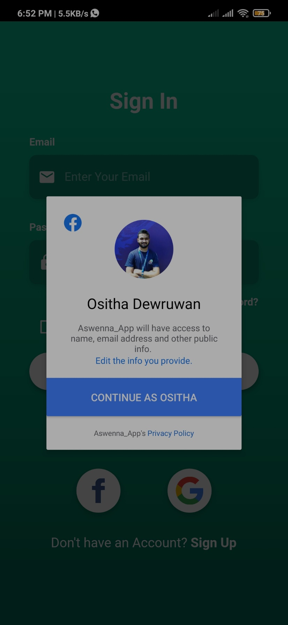

Figure 6 - Facebook Sign in Screen

## Collect User Data Screens

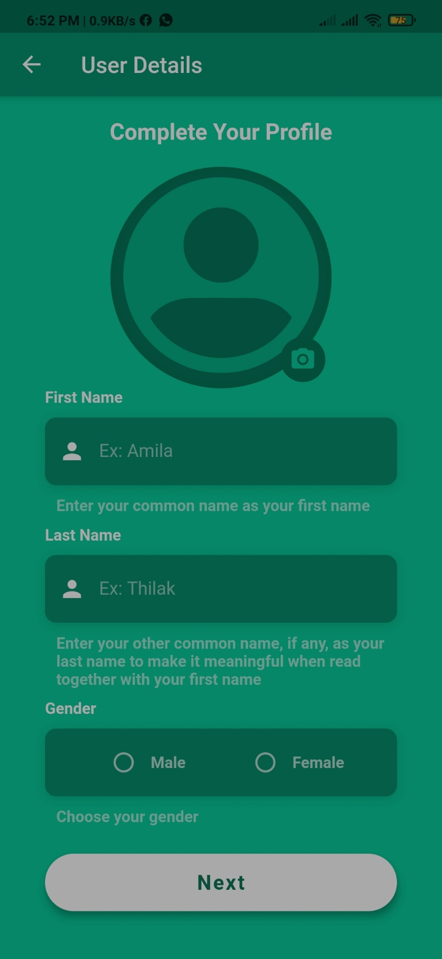

Figure 7 - Collect User Data Screen 01

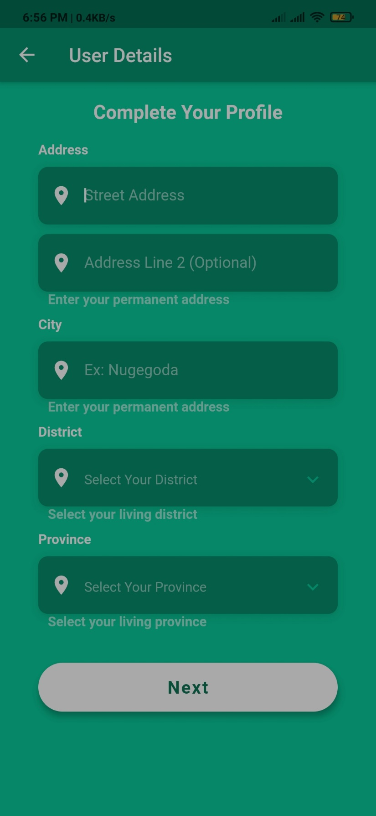

Figure 8 - Collect User Data Screen 02

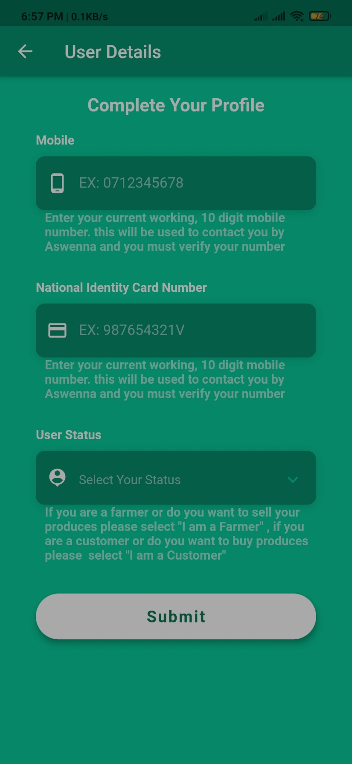

Figure 9 - Collect User Data Screen 03

## Customers Dashboard Screen

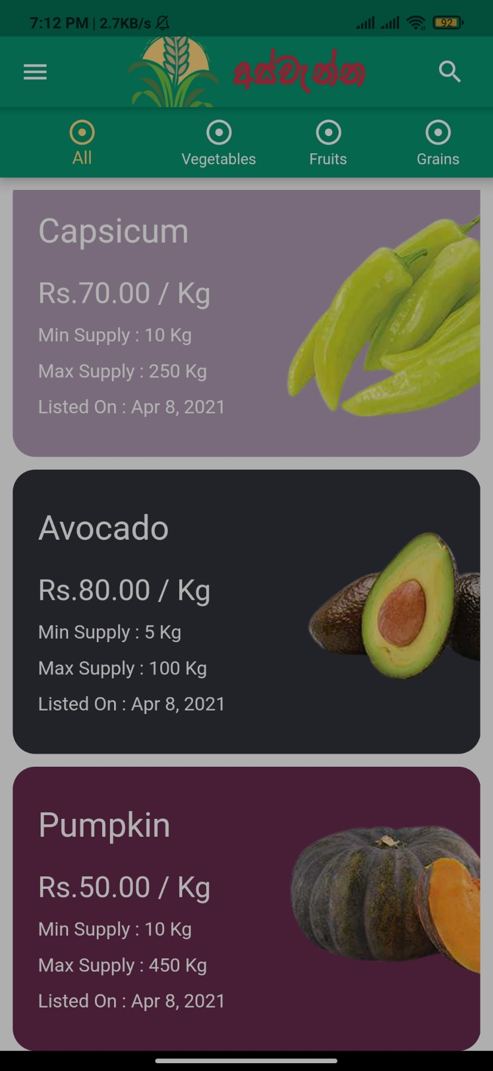

Figure 10 - Customer Dashboard All

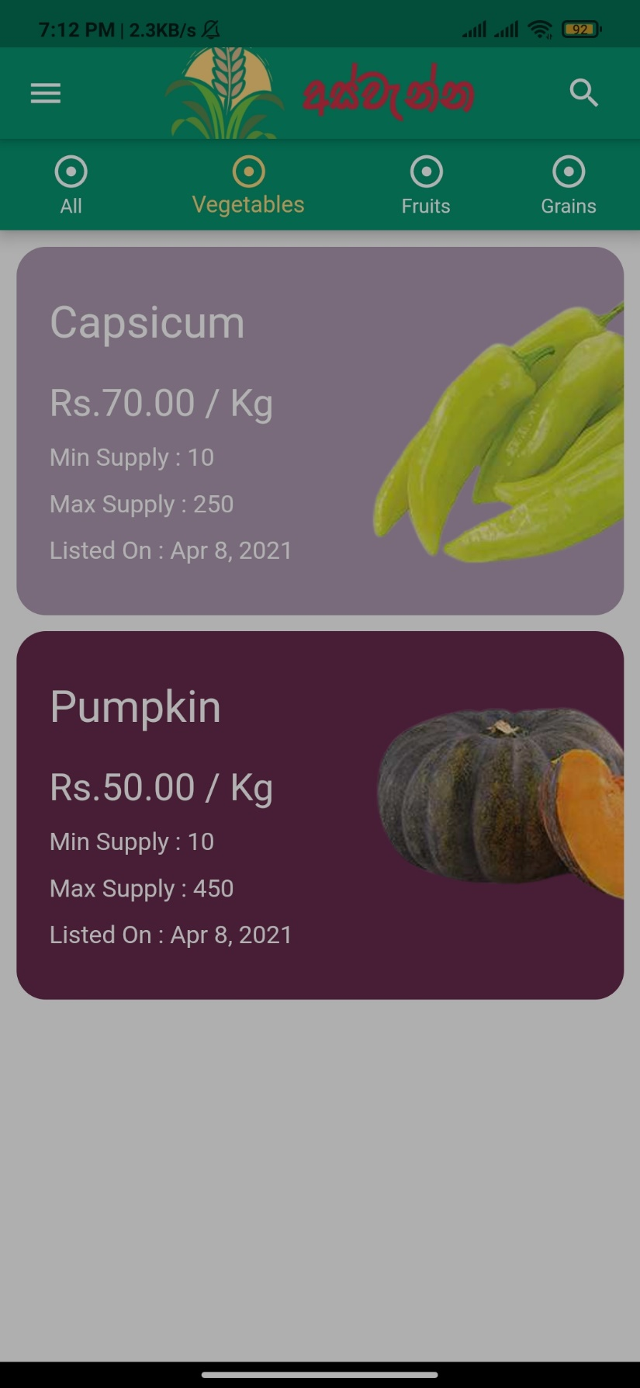

Figure 11 - Customer Dashboard Vegetables

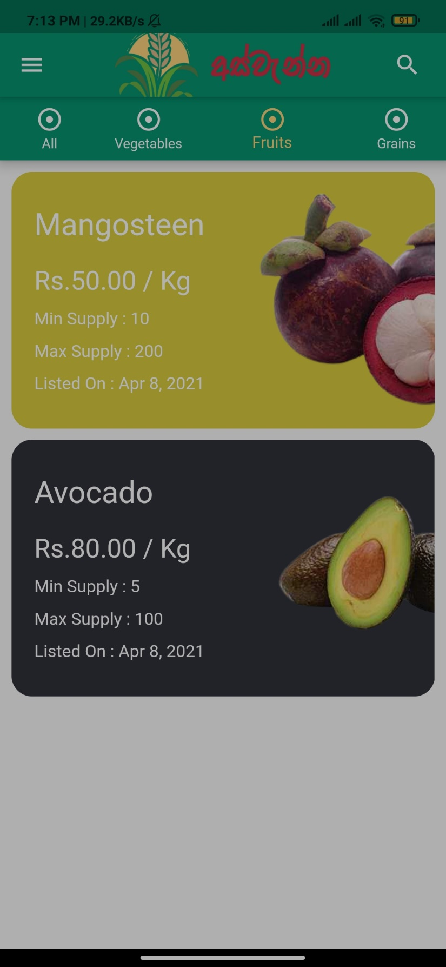

Figure 12 - Customer Dashboard Fruits

## Farmers Dashboard Screen

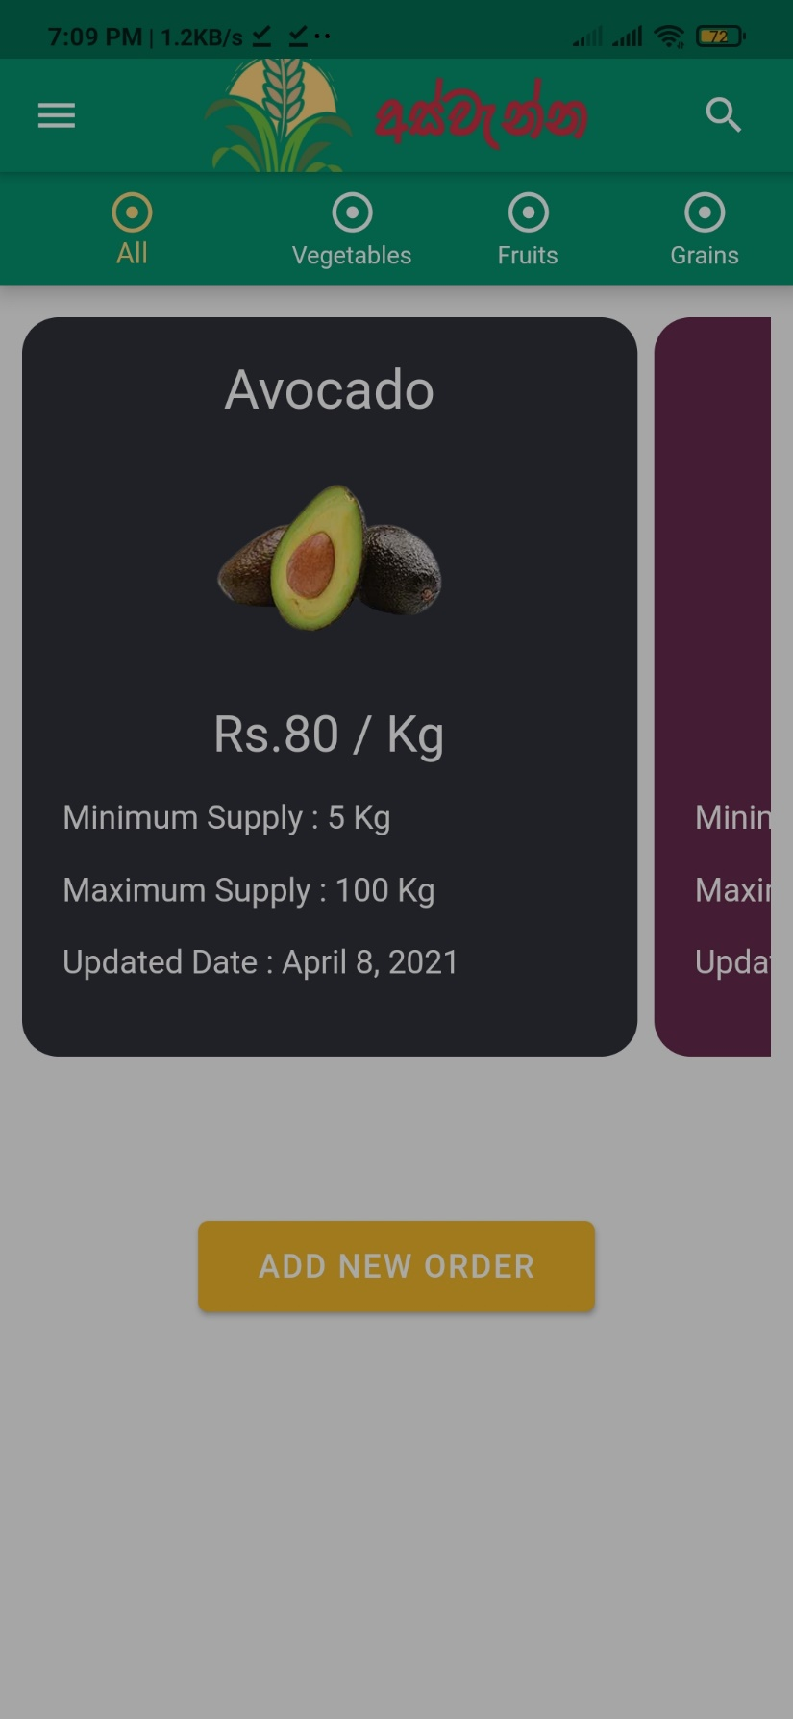

Figure 13 - Farmer Dashboard All

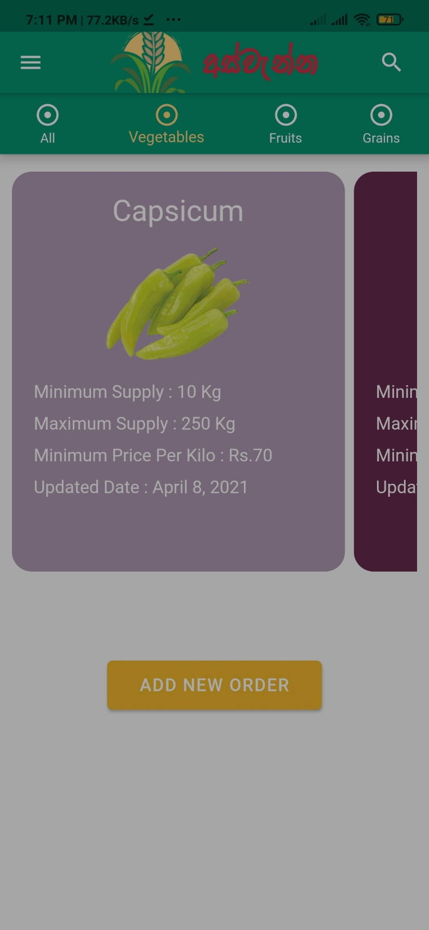

Figure 14 - Farmer Dashboard Vegetables

## Customer Product Details Screen

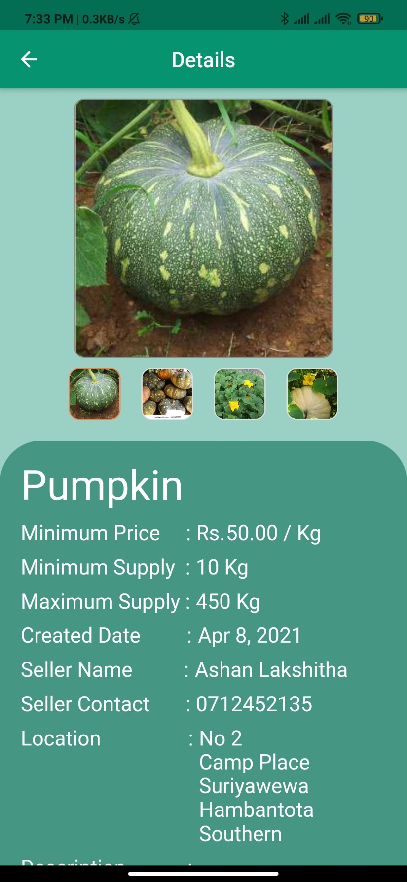

Figure 15 - Customer Product Detail Screen

## Farmer Product Detail Screen

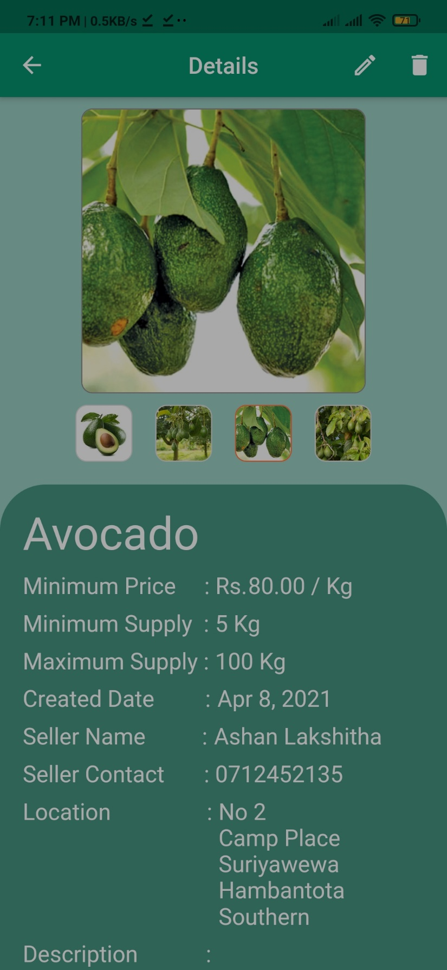

Figure 16 - Farmer Product Detail Screen

## Edit Product Option

Figure 17 - Product Edit Option



## Edit Product Screen

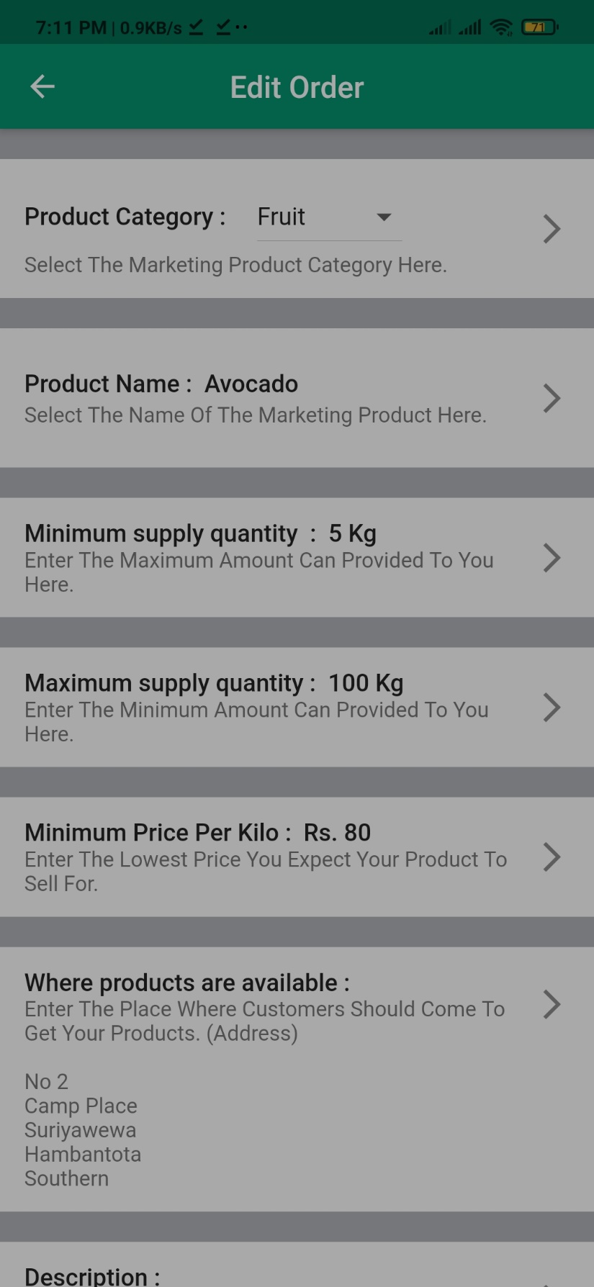

Figure 18 - Product Edit Screen 01

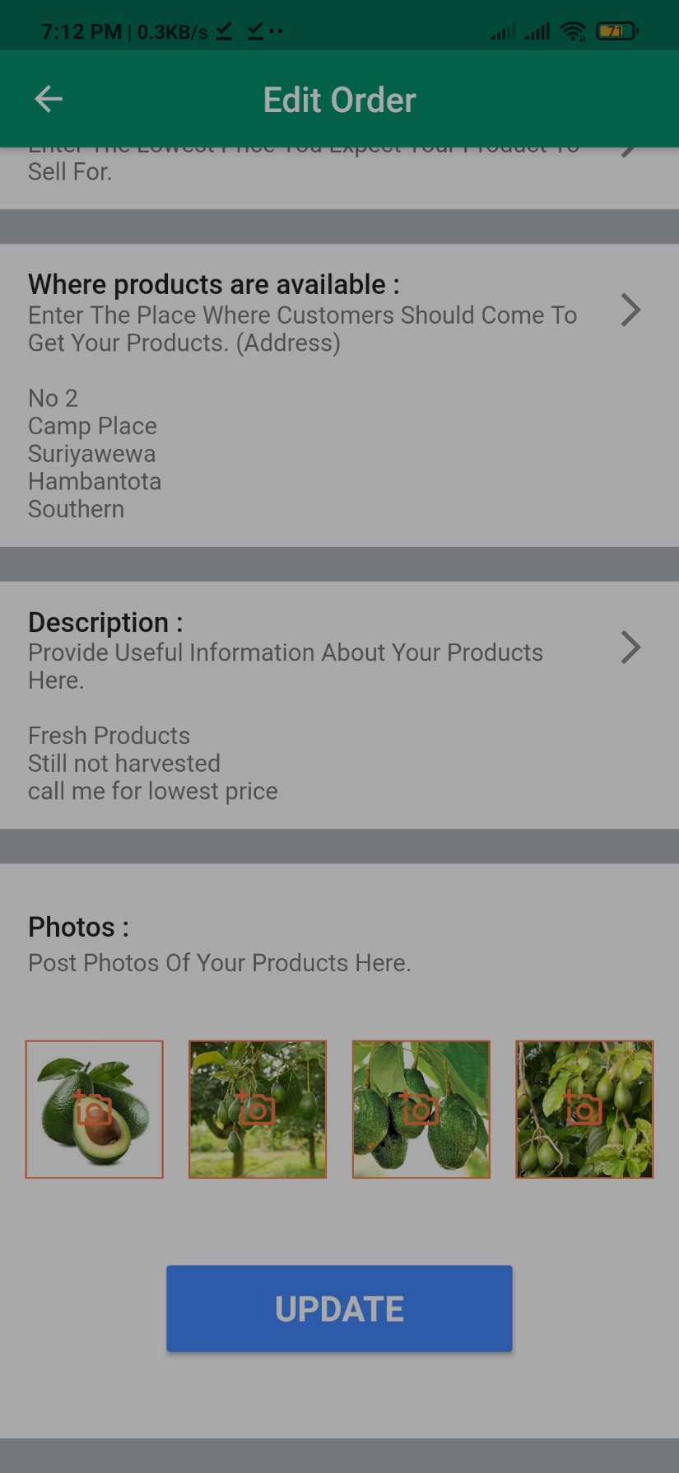

Figure 19 - Product Edit Screen 02

## Delete Product Option

Figure 20 - Product Delete Option



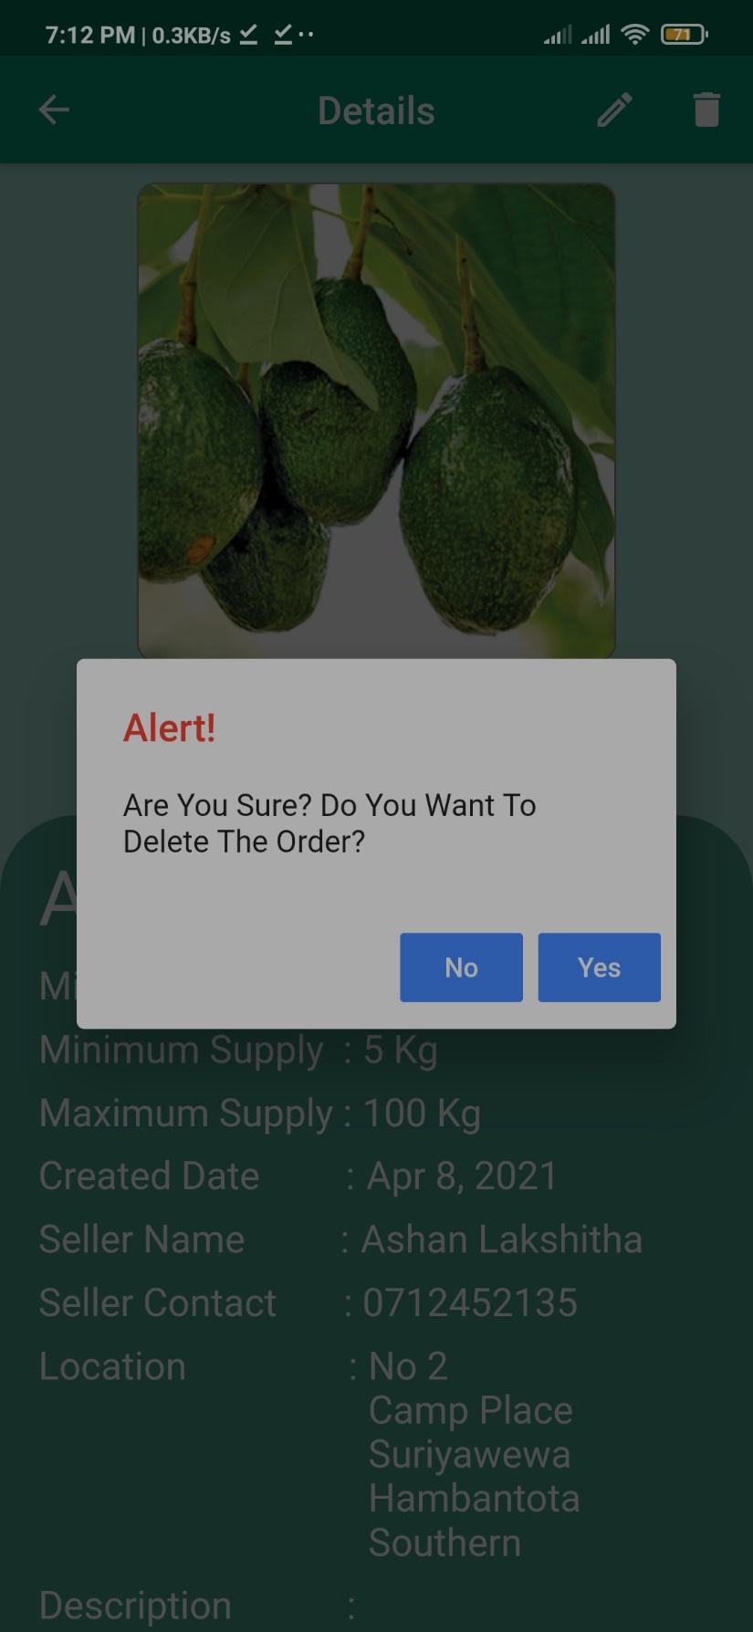

Figure 21 - Product Delete Confirmation

## Add Product Screen

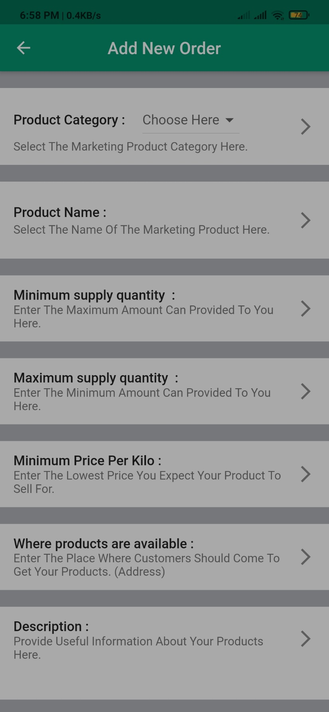

Figure 22 - Add New Product Screen 01

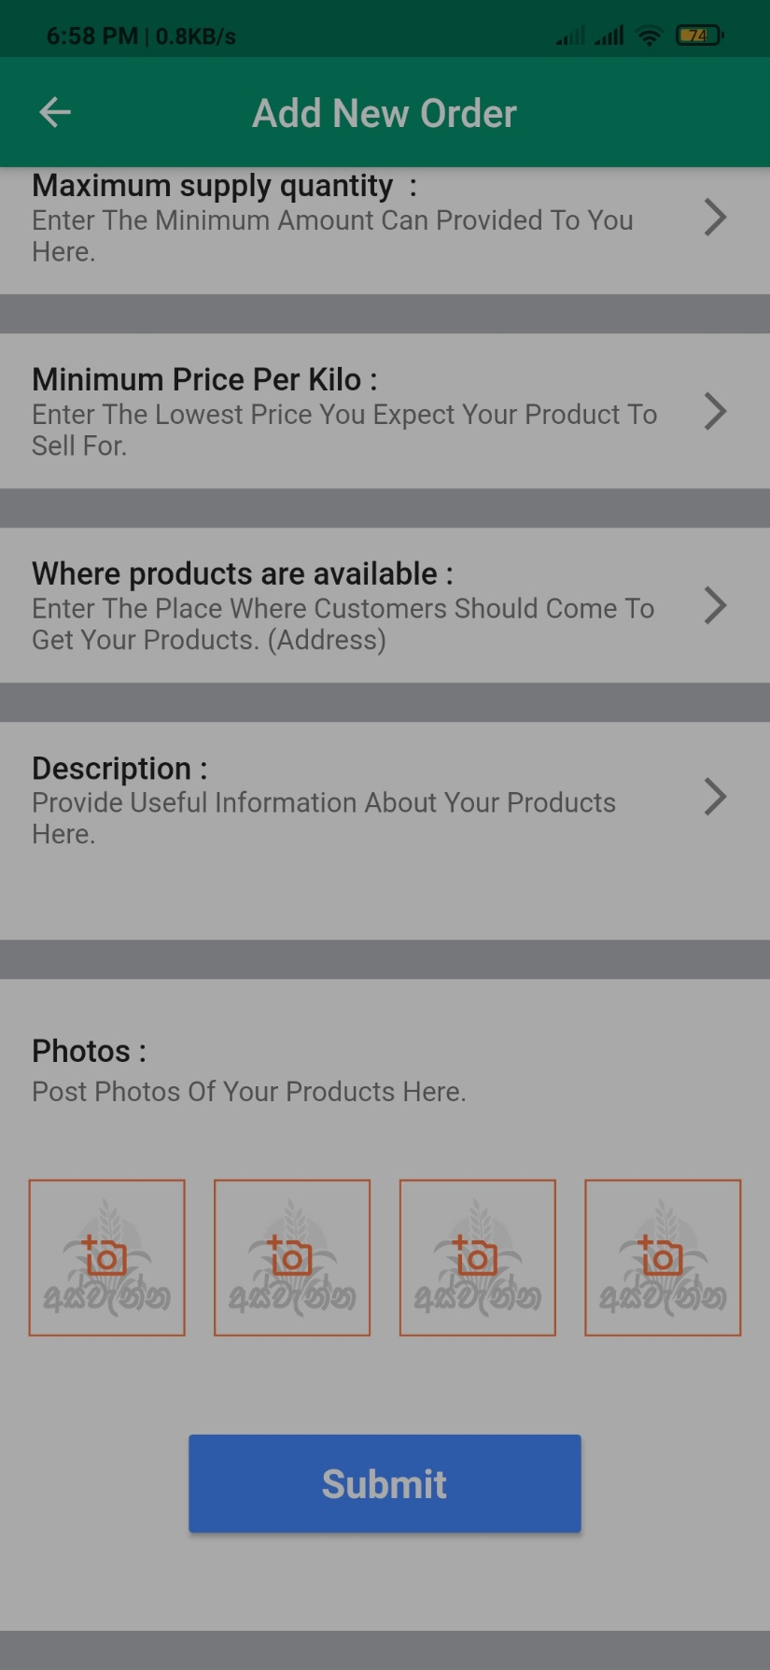

Figure 23 - Add New Product Screen 02

## Image Upload Screen

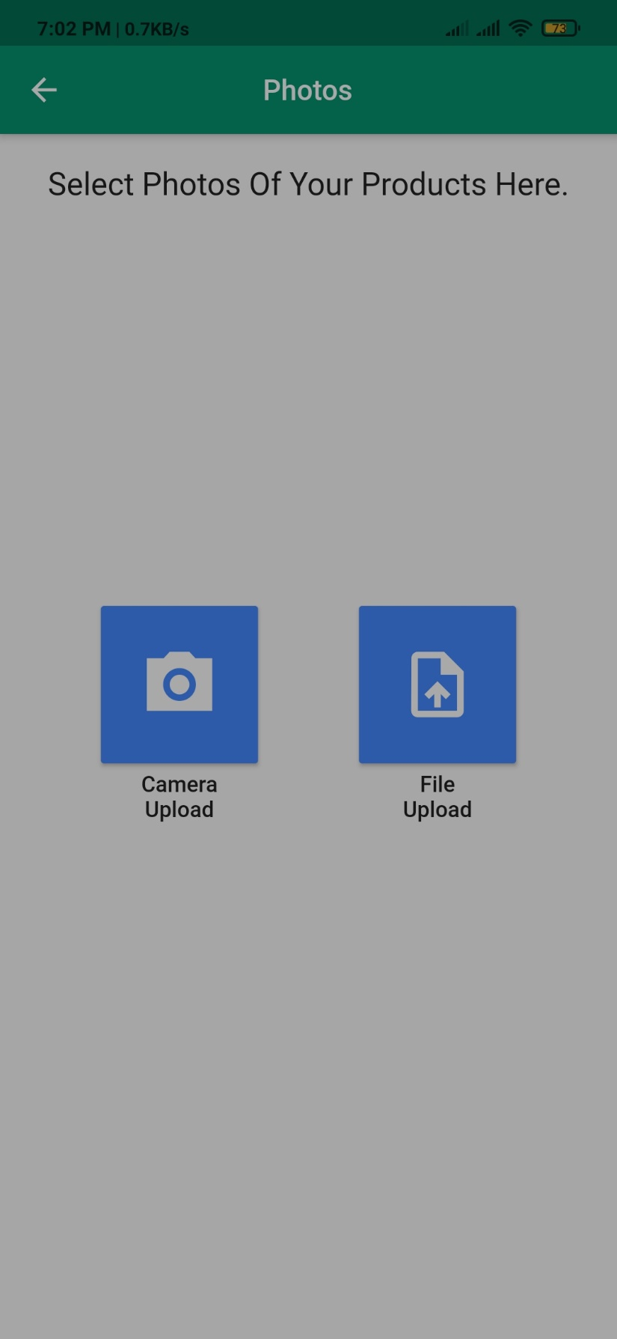

Figure 24 - Image Upload Screen

## Some Other Screens and Windows.

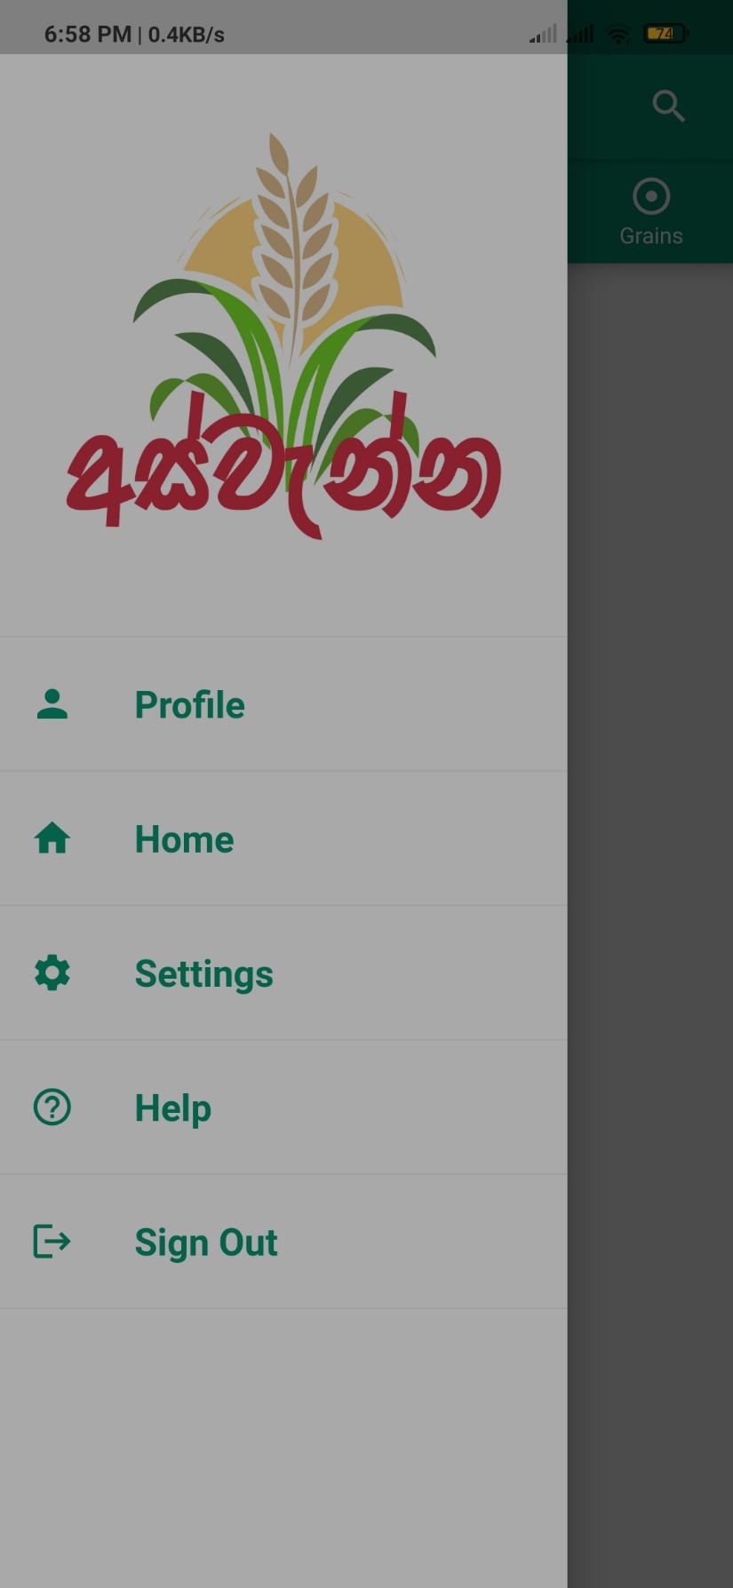

Figure 25 - App Drawer

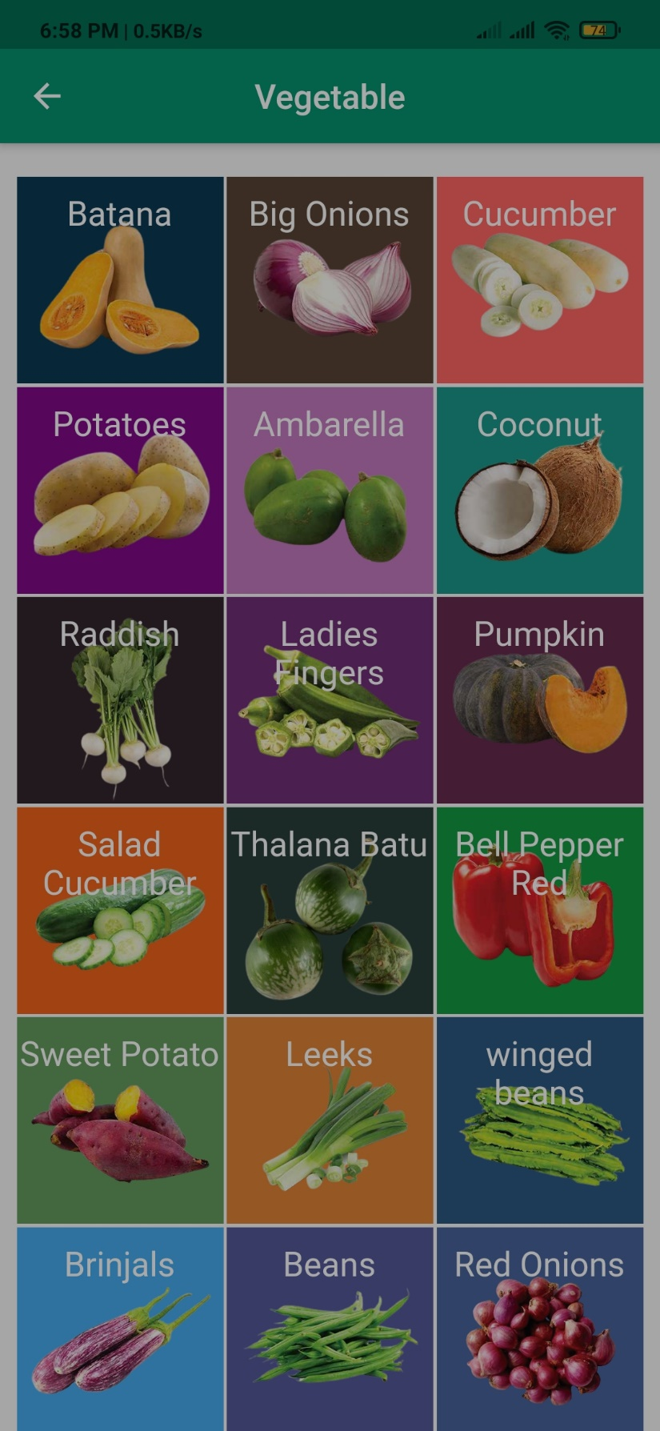

Figure 26 - Product Selection Screen Vegetable

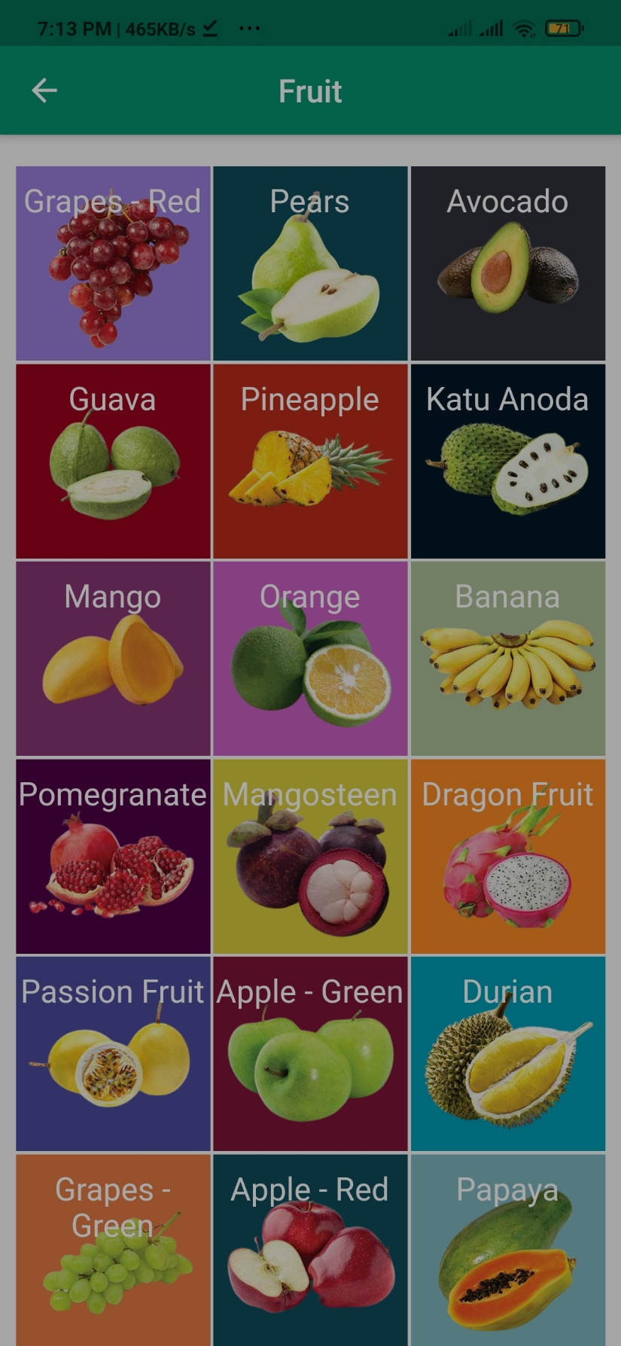

Figure 27 - Product Selection Screen Fruit

# Discussion

In this project, I used Flutter Framework and Dart language with Firebase Firestore, Firebase Authentication, and Firebase Storage Services. before I start to develop this application, I did simple research about interfaces and codding methods. I developed this application while self-studying about mobile app development and new technologies. I tried to design the application at the professional level. while I developing the app I got ideas and feedbacks from my friends I study other apps to get more ideas and knowledge. sometimes I faced some problems in interface designing. so I fixed those problems with the help of the "StackOverflow" knowledge-sharing community. the main problem I faced was handling Firebase Services. but finally, I could understand those problems and fix those. In the future, I expect to publish this project for the common society. also, I hope to combine transport service with this application and give a production delivery service for buyers through this app. and also I expect to give more knowledge about farming through this app. besides I try to communicate with government related departments and deliver their agricultural support to the farmers directly through this app.

# Conclusion

This project consists of a mobile application. The project's goal is to reduce the wastage of agricultural products and establish a market for farmers without brokers.  The mobile application (Aswenna) focuses on place an order of agricultural products before harvesting and makes direct interconnection among farmers and buyers.

# Reference

<https://stackoverflow.com/>

<https://levelup.gitconnected.com/>

<https://flutter.dev/>

<https://flutterforum.co/>

<https://pub.dev/>

<https://firebase.google.com/>

<https://firebase.flutter.dev/>

<https://www.tutorialspoint.com/>

<https://www.freecodecamp.org/>

<https://www.solutelabs.com/>

<https://hackr.io/>

<https://www.educative.io/>

<https://dart.dev/>

<https://www.mygreatlearning.com/>